# Imperial University Aff

## Ev Ethics

### 1nc

#### Interpretation: Debaters may not read evidence that was cut from the middle of a paragraph. The beginning of the card must coincide with the beginning of a paragraph, and the end of the card with the end of a paragraph.

#### Violation is the Chatterjee et al card. I have screenshots—the card starts and ends in the middle of paragraphs.

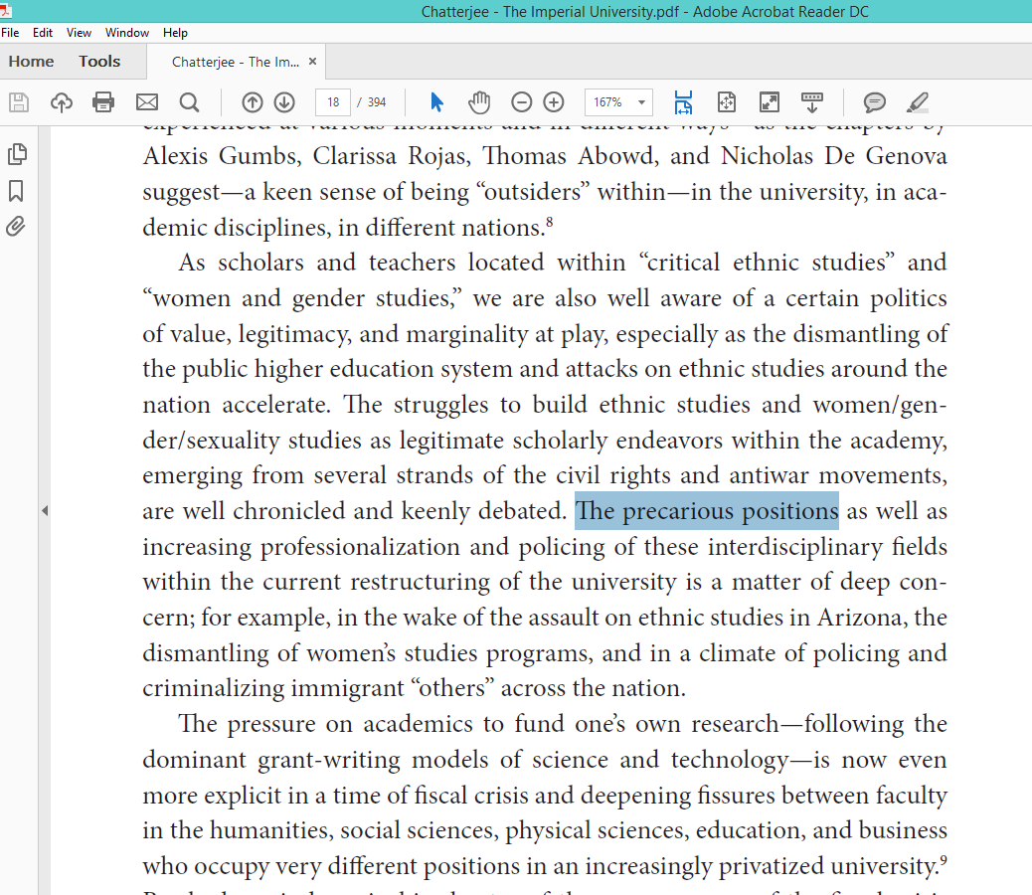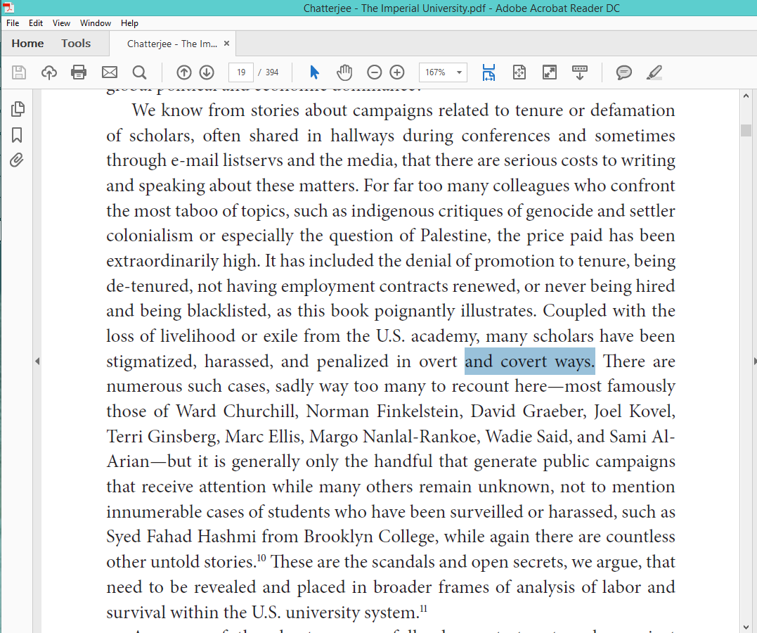

#### Standard’s evidence ethics—you make it super easy to distort evidence since you start and end in the middle of an author’s thought. No non-arbitrary cutoff—counter-interp justifies carding two random out of context sentences. Violates intellectual integrity. Also turns fairness—you can read insanely good out of context ev all the time that I can’t have ground against. And turns case—you distort and co-opt evidence like imperialism distorted and co-opted the academy. Last, whether or not the rest of the paragraphs contradict in this case is irrelevant since a] it’s a question of evidence norms, b] fact that they did this once means they might’ve done it again somewhere else and actually eliminated contradictory sentences, c] no briteline for what counts as sufficiently non-contradictory.

#### Evidence distortion is a voting issue—it violates intellectual integrity.

Torson 13 Adam Torson (Assistant Debate Coach at Harvard-Westlake) “Debate and the Virtue of Intellectual Integrity by Adam Torson.” 24 March 2013. Victory Briefs. http://victorybriefs.com/news/2013/3/debate-and-the-virtue-of-intellectual-integrity-by-adam-torson

Too often in debate, strategy devolves into sophistry. **Debaters utilize** a series of **tactics** designed only to muddy the water, **to obscure a fair evaluation of** the merits of their **arguments** by either judges or opponents. **This includes** the **distortion of evidence**, e.g. by reading cards out of context so as to make it seem that authors using terms differently actually intend the same meaning. It includes evasive or overly ambiguous explanations of arguments, designed to allow debaters to shift their positions in the rebuttals. It includes impossibly dense and blippy analytical frameworks with contingent standards, layers of unreasonable spikes, theory bait, and other tricks hidden throughout. **These tactics are inconsistent with** an ethic of **intellectual integrity.** The rules that we set up to make the debate game intellectually rigorous are exploited to separate us altogether from a meaningful contest of ideas; the tail wags the dog. A student deploying these tactics hopes to win not because he marshals the most compelling argument, but because his opponent makes a superficial error or his judge is too embarrassed to admit that he didn’t properly follow the argument. We hope that the practice of dialectic contestation will help us to challenge or confirm our beliefs on important personal and political questions. **Strategies of** purposeful **obfuscation**, on the other hand, **turn arguments into mere instruments of power** - ways of manipulating the circumstances to contrive a favorable outcome. **These** strategies **are disingenuous approaches to** thinking through **the topic because they are** fundamentally **unrelated to the** residual **quality of the arguments.** That bad arguments could reliably beat good ones should strike us as a very strange outcome in any debate event worthy of the name.

#### Impact outweighs: a] real-world significance—people get expelled from school all the time for tiny academic ethics violations, best to teach good norms now. b] Distortion is literally just super immoral whereas lack of fairness/education are just pragmatic instrumental deficits. c] Norming—my shell has norm-setting offense and is most likely to set norms since there are actual community norms about evidence unlike random theory issues. Means it outweighs on magnitude—I solve abuse in way more rounds. d] Precludes substance—distortion gives you an arbitrary advantage so the aff wasn’t legitimately tested and you can’t vote on it.

#### Drop the debater: a] deterrence—especially key for ev ethics since norming is super key, b] rectify the time loss for running theory, c] substance is permanently skewed since abuse affects all strategic developments.

#### Competing interps…

#### No RVIs…

## Plan Flaw

### 1nc

#### Plan flaw: the plan text doesn’t have a period.

#### College/university policies need proper punctuation.

RIT n.d. (Rochester Institute of Technology, “POLICY-SPECIFIC EDITORIAL GUIDELINES,” <https://www.rit.edu/academicaffairs/policiesmanual/policy-specific-editorial-guidelines>) OS

As indicated in the introduction to University Publications’ Grammar and Style Guide: Correct grammar, punctuation, and “style” may seem old-fashioned these days, but their absence in any communication from a university or other reputable and highly visible entity is frowned on, even by those who may not ordinarily pay much attention. Because RIT owes its public and its students the best—in its use of language as well as in programs, facilities, teaching, and service—University Publications provides this reference to grammatical rules, academic terminology, punctuation, etc. The guide relies on the Associated Press Stylebook, with additional references from the Chicago Manual of Style. In addition, when writing policy documents, individuals should be mindful that RIT’s university and administrative policies exist primarily on the web, not in print. RIT’s web standards, which can be found in the Brand Identity Manual, create a framework for proper use of language, graphics, and navigational architecture for all RIT-related websites, and RIT’s policy website conforms to these standards.

#### Voter:

#### [1] Presumption—no offense can be garnered if the plan isn’t implementable—presume neg since aff has the proactive burden of proving the resolution true

#### [2] Jurisdiction—you only have authority to endorse an actual advocacy

#### [3] Incentivizes being more careful in designing plans which is more educational and realistic

#### [4] Key to real-world education since the plan could never happen so there’s no point in debating it

## Neolib Good

### 1nc

#### Next is neolib good. They do not have an impact card so he cannot win. Be weary of questionable 1AR extensions—call for the 1AC.

#### [1] Turn—corporate influence and neolib are key to social progress. A million empirics prove.

Martinez ’15 (Andrés Martinez writes the Trade Winds column for our media partner Zócalo Public Square, where he is editorial director. He is also professor at the Walter Cronkite School of Journalism at Arizona State University. “Big Corporations Are Good for Social Progress,” 7/9, <http://www.people2power.info/op-ed/big-corporations-are-good-for-social-progress/>) OS

Maybe we would all benefit if corporations wielded more political power, not less. Ever since the US Supreme Court’s Citizens United decision in 2010, it’s been fashionable to deplore (with full-on How dare they? indignation) the power of big business in our political process. But judging from recent events, I’m more inclined to regret that corporations don’t have a greater say in our civic life. Seriously. Think about the recent rash of exhilarating triumphs for once-marginalized minorities in the United States: the U.S. Supreme Court legalizing gay marriage across the land; South Carolina hastening to lower the Confederate flag of sedition and racism; a Republican presidential candidate being ostracized for bashing Latino immigrants. One of the threads connecting each of these stories is the presence of corporate America flexing its muscles, taking a stand against the bullying and discrimination of minorities. The case for same-sex marriage In the landmark marriage case, a Who’s Who list of blue-chip companies from Procter & Gamble to Goldman Sachs signed onto legal briefs urging the justices to strike down all bans on gay marriage. They argued that such bans conflict with their own anti-discrimination and diversity policies, and that you can’t have a country (and cohesive marketplace) where fundamental rights – like the right to marry — vary from state to state. Even more impressively, big business mobilized in a number of states over the past two years to defeat or roll back proposed “religious freedom” laws seen as disingenuous efforts to legitimize the discrimination of gays. No single company has been more identified with the effort to stand up to such laws than Walmart, which was credited with singlehandedly defeating a proposed measure in its home state of Arkansas. The retailer also joined other prominent businesses in attacking another such law passed in Indiana, which was subsequently altered. Business interests were also instrumental in turning the tide against the Confederacy. The New York Times story on South Carolina Governor Nikki Haley’s decision to call for the removal of the Confederate flag from the State Capitol grounds in the aftermath of the racially-motivated massacre at the Emanuel Church credited “intensifying pressure from South Carolina business leaders to remove a controversial vestige of the state’s past” as one factor leading to the governor’s reversal of her previous position. Active business-community Arizona is another state where businesses leaders fought against, and defeated, a religious freedom law that would have otherwise prevailed. In addition, establishment Republicans and corporate leaders in the Grand Canyon State have been in full damage-control mode since the state legislature passed SB 1070, a controversial anti-immigration measure which proved disastrous to the state’s brand as a tourism and investment destination. Subsequently, the business community mobilized to defeat a number of other, ever more radical, anti-immigrant proposed laws in the state, and to take on the Tea Party Republicans responsible for them. The case for immigration At the national level, the U.S. Chamber of Commerce and other business groups have led the charge for sensible immigration reform – though this effort can’t yet be checked off as a victory. If only the business lobby had as much power as we often assume it does! In the meantime, it was gratifying for Latino activists aligned with business on immigration to watch Donald Trump be fired by corporate partners like Macy’s, Comcast, Univision, and Disney over his hateful comments about Mexicans. Turns out, vicious speech denigrating immigrants may be acceptable speech in certain political circles, but not in the corporate realm. Some politicians eager to cater to local prejudices, and capitalize on them, are clearly chafing at the activism of corporations on behalf of a healthier business climate. This spring, while pushing for his own religious freedom law, Louisiana Governor Bobby Jindal practically whined in a New York Times op-ed: “As the fight for religious liberty moves to Louisiana, I have a clear message for any corporation that contemplates bullying our state: Save your breath.” It’s an interesting line, not only because he ascribed “breath” to companies, doubling down on the much-mocked pronouncement of then-candidate Mitt Romney that companies are essentially people, too. Jindal’s choice of the verb “bullying” is deliciously hypocritical, because in this case (as in the others described above), it was business rising up to oppose the bullying of people by small-minded politicians. Anti-corporate worldview And this is the key issue on which I differ from many of my friends and colleagues in journalism and academia who hold to a reflexively anti-corporate worldview. They see large, distant corporations as the source of much bullying. I tend to see the worst forms of bullying arising closer to home: at the hands of local or state governments, or dominant business interests rooted in one place. No, there isn’t anything inherently virtuous about business leaders. As cynics are quick to note, the political fights I’ve described here are all about business wanting what’s best for business. Companies need to avoid offending existing or potential customers and they need to be seen as being inclusive and diverse employers to the best and brightest potential hires out there. I’ll still take those selfish impulses: If only more governments were similarly motivated, instead of being willing to marginalize minorities. Most business lobbying is admittedly not focused on civic or “business climate” issues like the ones I am raising, but rather on narrower, self-interested agendas of particular companies or industries – say, to influence the drafting or application of regulations, or tax laws. Critics resent the billions spent by corporations and their trade associations in trying to influence the political process, especially since the amounts they spend dwarf the lobbying expenditures of everyone else. But lost in the depiction of a monolithic corporate America pitted against the rest of us, getting its way behind closed doors, is the fact that a significant portion of those business lobbying efforts and dollars are essentially engaged in an intramural corporate contest. It’s about one industry or company seeking to gain advantage (or a level playing field, they might say) against a competitor. Those dollars often cancel each other out. But when the business community does come together to speak with one voice, on broader issues affecting us all, it tends to play a powerful and positive role. Beneficial trade agreements Big business tends to be more enlightened than smaller business interests rooted in only one place, because the broader your perspective, the bigger your market, the less tolerant you can afford to be of idiosyncratic regional prejudices. A company with customers and employees across the country or around the world won’t be comfortable choosing as its home a state that embraces symbols associated with the cause of slavery, or one that passes laws that treat gay couples as second-class citizens or one perceived to be harassing foreigners. It’s no accident that commerce across state lines has always been one of the great motors of progress in this country, and not just economic progress. That is also why trade agreements that seek to harmonize norms across borders are as beneficial to individuals as they are to big multinationals. The prospect of joining the European Union (and attracting investment by large foreign companies) forced governments across Eastern Europe to protect the rights of long-oppressed minorities. As much as Elizabeth Warren and her protectionist allies have attacked President Obama’s proposed trade deal with Asia as a sop to big business, the agreement will help strengthen civil society and individual rights in these countries for precisely the reasons these critics attack it – by standardizing norms of behavior across jurisdictions. Bigotry, and the disregard of people’s rights and dignity that comes with it, don’t travel well. And they’re bad for business.

#### Outweighs:

#### [a] Role of the ballot—even if you win some random specific internal link scenario, it’s about “liberation strategies”—criticizing neolib is a bad one.

#### [b] Virtuous cycle—even if neolib causes some injustice now, it’s self-correcting because it involves an incentive for social justice. Long-term resolves the harms.

#### [c] I control uniqueness—my ev indicates people are very critical of neolib now. We literally elected a populist protectionist president who promises to “drain the swamp” of corporate influence. Means squo solves the aff and my offense comes first.

#### [2] Neolib solves poverty and oppression.

Chen 2k

(Jim, MN Law School, “ESSAY: PAX MERCATORIA: GLOBALIZATION AS A SECOND CHANCE AT "PEACE FOR OUR TIME”, 24 Fordham Int'l L.J. 217, lexis)

The antiglobalization movement has made some extraordinary claims. Let us transplant a precept of natural science into this social realm: n177 extraordinary claims demand extraordinary proof. n178 From Seattle to Prague, protesters have argued that the organs of international economic law conspire with multinational corporations to sap national and local governments of legitimate power, to destabilize global security, and to poison workplaces as well as ecosystems. n179 That case has not met even the most generous standard of proof. The antiglobalization movement has failed to refute the following: Dramatic improvements in welfare at every wealth and income [*246] level. n180 Since 1820 global wealth has expanded tenfold, thanks largely to technological advances and the erosion of barriers to trade. n181 The world economic order, simply put, is lifting people out of poverty. According to the World Bank, the percentage of the world's population living in extreme poverty fell from 28.3 to 23.4% between 1987 and 1998. n182 (The World Bank defines extreme and absolute poverty according to "reference lines set at $ 1 and $ 2 per day" in 1993 terms, adjusted for "the relative purchasing power of currencies across countries.") n183 A more optimistic study has concluded that "the share of the world's population earning less than US$ 2 per day shrank by more than half" between 1980 and 1990, "from 34 to 16.6 percent." n184 In concrete terms, "economic growth associated with globalization" over the course of that decade helped lift 1.4 billion people out of absolute poverty. n185 Whatever its precise magnitude, this improvement in global welfare has taken place because of, not in spite of, flourishing world trade. n186 The meaning of American victory in the Cold War. The liberal democracies of the north Atlantic alliance decisively defeated their primary political rivals in the Eastern bloc. Capitalism coupled with generous civil liberties crushed central planning coupled with dictatorship of the proletariat. "America, so the world supposes, won the Cold War." n187 And the world is right. The true nature of the environmental crisis. The most serious environmental problems involve "the depletion and destruction of the global commons." n188 Climate change, ozone depletion, [*247] and the loss of species, habitats, and biodiversity are today's top environmental priorities. n189 None can be solved without substantial economic development and intense international cooperation. The systematic degradation of the biosphere respects no political boundaries. Worse, it is exacerbated by poverty. Of the myriad environmental problems in this mutually dependent world, "persistent poverty may turn out to be the most aggravating and destructive." n190 We must remember "above all else" that "human degradation and deprivation ... constitute the greatest threat not only to national, regional, and world security, but to essential life-supporting ecological systems." n191 The enhancement of individual liberty through globalization. By dislodging local tyrants and ideologies, globalization has minimized the sort of personal abuse that too often seems endemic to one place, one population. n192 The twenty-first century will witness "people voting with their feet to escape from some village elder's idea of how to live, or some London School of Economics graduate's idea of protecting Indian folkways." n193 This changing social reality will undermine the conventional assumption that capital is mobile but labor is immobile. Generations of scholarship on trade and international relations hang in the balance. At the very least we will have to recalibrate existing race-to-the-bottom models and their sensitivity to "giant sucking sounds." [*248] Nor has localism propounded plausible solutions to challenges such as food security, n194 AIDS and other epidemiological crises, and barriers to full equality for women and children. n195 The localist package of autarky, retaliatory protectionism, and isolationism would be catastrophic. It really is a shame that Ralph Nader will probably not be named "the first U.S. ambassador to North Korea," where he could "get a real taste of what a country that actually follows [his] insane economic philosophy - high protectionism, economic autarky, anti-markets, antiglobalization, anti-multinationals - is like for the people who live there." n196 The policies preferred by the protesters at Seattle and Prague guarantee penury for most, security for some, and power for an unjustly privileged few. That way runs anew the road to serfdom. n197

#### Outweighs on magnitude—complete poverty and authoritarian repression are worse than limits to academic freedom.

#### [3] Impact defense—their catch-all use of neolib is absurd—neolib can’t be a coherent hegemonic project. Neg specificity outweighs.

Barnett, Open University social sciences faculty, 2005

(Clive, “The consolations of ‘neoliberalism”, Geoforum, ebsco)

The blind-spot in theories of neoliberalism—whether neo-Marxist and Foucauldian—comes with trying to account for how top-down initiatives ‘take’ in everyday situations. So perhaps the best thing to do is to stop thinking of “neoliberalism” as a coherent “hegemonic” project altogether. For all its apparent critical force, the vocabulary of “neoliberalism” and “neoliberalization” in fact provides a double consolation for leftist academics: it supplies us with plentiful opportunities for unveiling the real workings of hegemonic ideologies in a characteristic gesture of revelation; and in so doing, it invites us to align our own professional roles with the activities of various actors “out there”, who are always framed as engaging in resistance or contestation. The conceptualization of “neoliberalism” as a “hegemonic” project does not need refining by adding a splash of Foucault. Perhaps we should try to do without the concept of “neoliberalism” altogether, because it might actually compound rather than aid in the task of figuring out how the world works and how it changes. One reason for this is that, between an overly economistic derivation of political economy and an overly statist rendition of governmentality, stories about “neoliberalism” manage to reduce the understanding of social relations to a residual effect of hegemonic projects and/or governmental programmes of rule (see Clarke, 2004a). Stories about “neoliberalism” pay little attention to the pro-active role of socio-cultural processes in provoking changes in modes of governance, policy, and regulation. Consider the example of the restructuring of public services such as health care, education, and criminal justice in the UK over the last two or three decades. This can easily be thought of in terms of a ‘‘hegemonic’’ project of “neoliberalization”, and certainly one dimension of this process has been a form of anti-statism that has rhetorically contrasted market provision against the rigidities of the state. But in fact these ongoing changes in the terms of public-policy debate involve a combination of different factors that add up to a much more dispersed populist reorientation in policy, politics, and culture. These factors include changing consumer expectations, involving shifts in bexpectations towards public entitlements which follow from the generalization of consumerism; the decline of deference, involving shifts in conventions and hierarchies of taste, trust, access, and expertise; and the refusals of the subordinated, refer- ring to the emergence of anti-paternalist attitudes found in, for example, women’s health movements or anti-psychiatry movements. They include also the development of the politics of difference, involving the emergence of discourses of institutional discrimination based on gender, sexuality, race, and disability. This has disrupted the ways in which welfare agencies think about inequality, helping to generate the emergence of contested inequalities, in which policies aimed at addressing inequalities of class and income develop an ever more expansive dynamic of expectation that public services should address other kinds of inequality as well (see Clarke, 2004b). None of these populist tendencies is simply an expression of a singular “hegemonic” project of “neoliberalization”. They are effects of much longer rhythms of socio-cultural change that emanate from the bottom-up. It seems just as plausible to suppose that what we have come to recognise as “hegemonic neoliberalism” is a muddled set of ad hoc, opportunistic accommodations to these unstable dynamics of social change as it is to think of it as the outcome of highly coherent political-ideological projects. Processes of privatization, market liberalization, and de-regulation have often followed an ironic pattern in so far as they have been triggered by citizens’ movements arguing from the left of the political spectrum against the rigidities of statist forms of social policy and welfare provision in the name of greater autonomy, equality, and participation (e.g. Horwitz, 1989). The political re-alignments of the last three or four decades cannot therefore be adequately understood in terms of a straightforward shift from the left to the right, from values of collectivism to values of individualism, or as a re-imposition of class power. The emergence and generalization of this populist ethos has much longer, deeper, and wider roots than those ascribed to “hegemonic neoliberalism”. And it also points towards the extent to which easily the most widely resonant political rationality in the world today is not right-wing market liberalism at all, but is, rather, the polyvalent discourse of ‘‘democracy’’ (see Barnett and Low, 2004).

#### The 1AR only has two kinda-impacts he can extend.

#### [a] The squashing dissent arg—but this is impacted to neolib! My turns also impact turn this since any dissent would be bad. At best they have minor violations of academic freedom but my turns massively outweigh on magnitude.

#### [b] The prison-industrial complex arg—but your ev is horrible. It just says banning things mirrors a logic of criminality, but vague associations with the *concept* of the P.I.C. don’t equate to actual oppression impacts. Prefer tangible impacts from the turns.

## Defense

### 1nc